safeguarding and visitor information
Safeguarding Statement
At Sheriff Hutton Primary School, we are committed to safeguarding and promoting the welfare of children. We expect all staff, volunteers, and visitors to share this common commitment.
This leaflet contains information about our expectations of you whilst visiting the school. If you are unclear about anything in it, please speak to any of the contacts named within.
Visitor Procedures
- Visitors must sign in at reception.
- A visitor badge and lanyard must be worn and be visible whilst on the school site.
- Visitors should remain under the supervision of a member of staff whilst on site.
- All visitors must sign out and return their visitor pass before leaving the site.
- Please wait in reception until a member of staff escorts you to where you need to be.
- You will be asked of you have any allergies we need to be aware of.

Sheriff Hutton Primary School’s Designated Safeguarding Team
If you are concerned about the safety of any child in our school, you must report this to one of the Designated Safeguarding Leads (DSL).
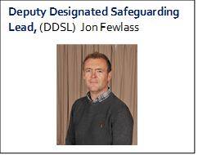
Deputy Designated Safeguarding Lead, (DDSL) Danielle Pearson
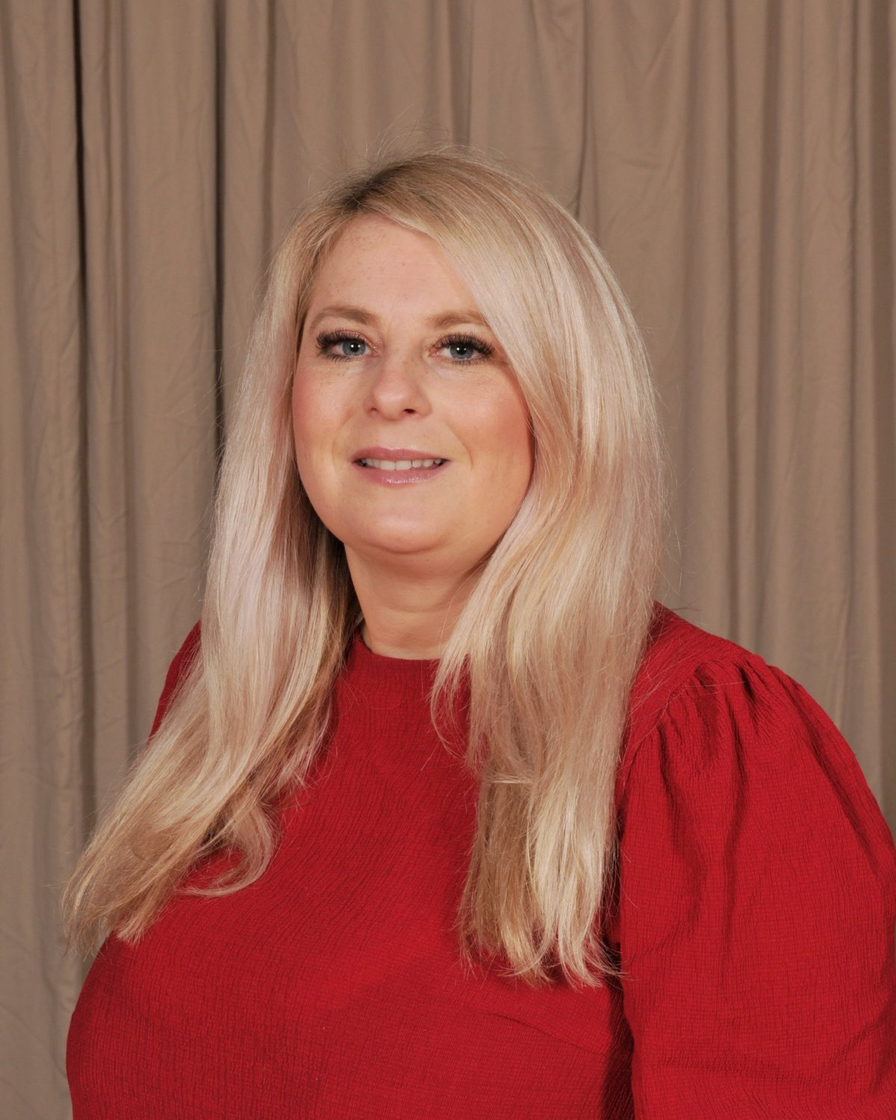

Safeguarding Lead, (DSL), Bev Stell
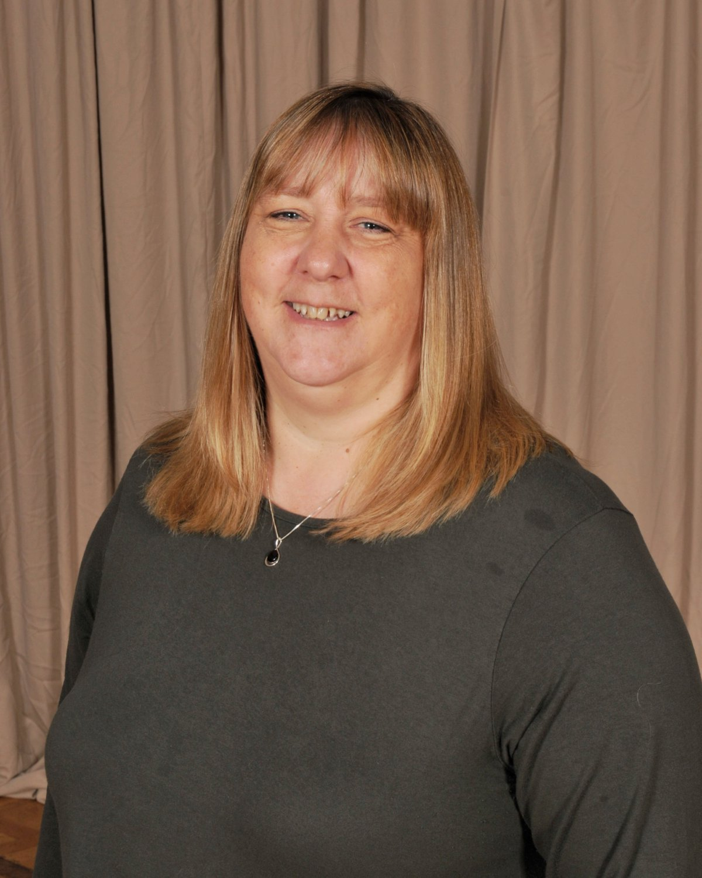

Safeguarding Governor – Elizabeth Galfe
What do I do if a child discloses that they are being harmed?
- React calmly and listen carefully to the child
- Tell them that you need to tell someone else – you cannot promise confidentiality.
- Make accurate notes of what has been said and asked to speak immediately to one of the safeguarding team.
It is not your responsibility to investigate but to report the information to the DSL or DDSL.
Staff Conduct
If you are concerned about the conduct of a member of staff during your visit, the following actions must take place:
- Immediately inform the Headteacher
- In their absence, immediately inform the DSL / DDSL
Our Safeguarding Team information is displayed throughout the school site and on our Website should you require further information.
Visitor Code of Conduct
- Treat everyone with respect
- Act as a positive role model
- Inform a member staff of any inappropriate behaviour witnessed
- Ensure you are visible by a member of staff if you are working with children.
- Never share personal information with a pupil
- You must not have any physical contact with a pupil
- Do not leave equipment unattended.
- Keep information confidential.
Mobile Phone, Devices & Photographs / SMART watches
The use of personal mobile phones or devices is strictly not permitted whilst on the school site. No photography is allowed unless permission is given by the headteacher.
In case of a Fire
In the unlikely event of the fire alarm sounding, please evacuate the school and proceed to the assembly point at the rear of the playground. Please exit by the nearest doors as directed by a member of school staff.
Lockdown
A lockdown is implemented when there is a serious risk outside of the school premises, Example excessive pollution or an unauthorised person on the school premises.
The lockdown alarm is a repeated long whistle.
You must enter the nearest room and follow the instruction of the staff.
Invacuation
Please enter the main building and go to the hall where you will be met by a member of staff.
The invacuation alarm is a repeated long whistle.
Smoking/Vaping is not permitted on the school site.
Accidents and Illness:
All accidents, regardless of severity, need to be reported to a first aider. Staff will inform you of the first aider nearest to where you are based. All accidents will be logged in the accident book
Supervision of tools
If you are completing work on the school site, please make sure that you do not leave tools/materials lying around unsupervised at any time during the day.
Toilet facilities
Under no circumstances can children’s toilets be used by adults. Use the male and female toilets located near reception.
Worried About a Child? Contact the Multi Agency Screening Team (MAST) - 0300 131 2 131


Duty Local Authority Designated Officer – LADO / lado@northyorks.gov.uk or 01609 533080


